**Project Design Phase-I**

**Solution Architecture**

|  |  |
| --- | --- |
| Date | 19 September 2022 |
| Team ID | PNT2022TMID27049 |
| Project Name | Fertilizer recommendation for disease prediction |
| Maximum Marks | 4 Marks |

**Example - Solution Architecture Diagram:**

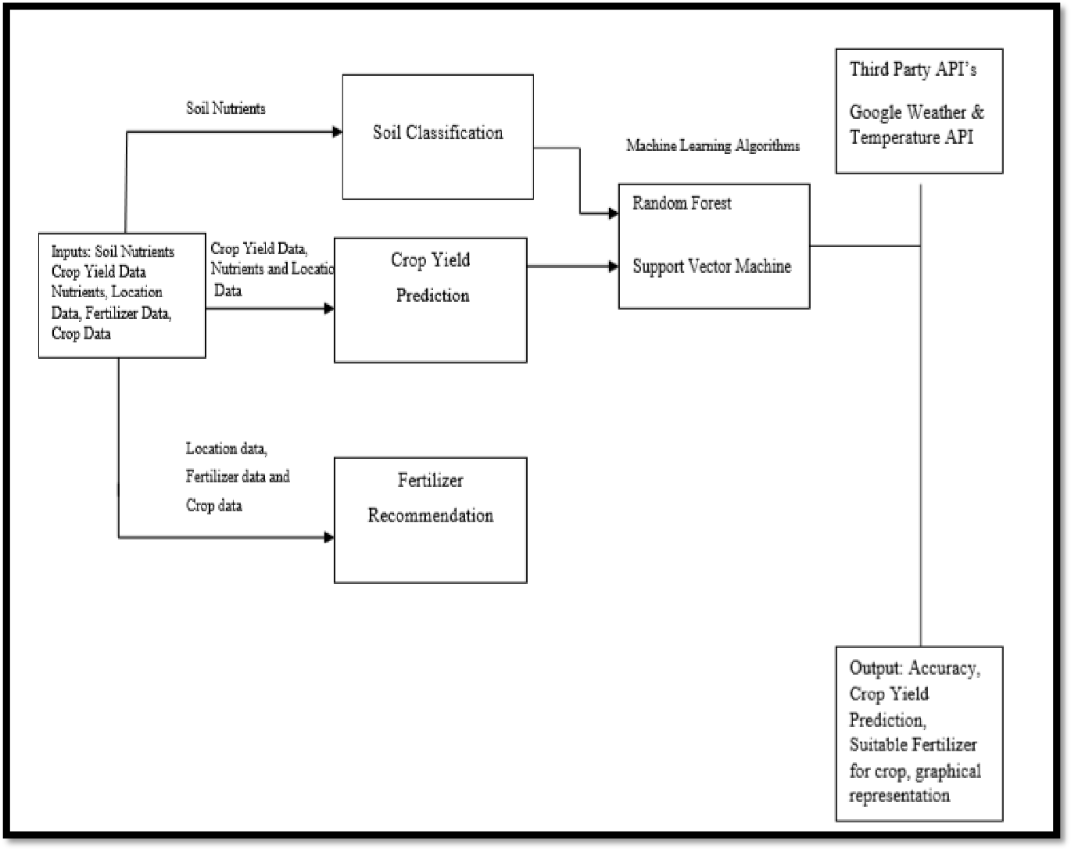

**Reference: http://www.ijstr.org/final-print/nov2019/Fertilizers-Recommendation-System-For-Disease-Prediction-In-Tree-Leave.pdf**